Symantec Endpoint – Home Edition
  - For home use, we provide an unmanaged version of Symantec Endpoint Protection.

We only provide very limited support for the home version of SEP, but here is the required information for installing the program.
- Download the installation files for SEP.
Typically, you can find the installation files in the “temp share” folder on the VAI network. Please contact the Help Desk if you are unable to locate them. There are separate folders for each Operating System (Windows 64-bit, Windows 32-bit, Mac OSX, and Linux).
To determine which version you need, find the link to “System” in the Control Panel. This screen should indicate what version of Windows you are currently running.
Copy the file to the Desktop of the computer that you wish to install it on.
- Proceed with installing Symantec.
You should be able to double-click the downloaded file to extract the folder and start the installation. It should be relatively straightforward install, and will likely require a reboot upon completion.
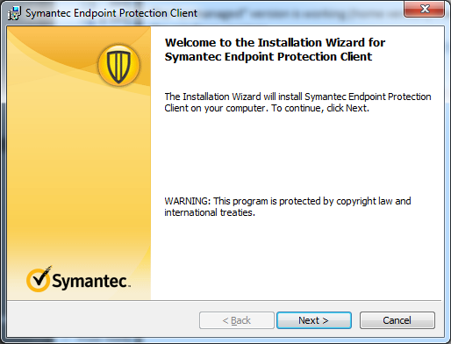
- Delete installation files.
Once complete, you can delete both the originally downloaded Symantec_Endpoint_Protection_12.1.6.exe file and the extracted folder (both should be on your desktop).

